Comments for Adjusting:

For CSV exports for leave requests and entitlements

As Chinese characters cannot be displayed in CSV files, so if can export buttons on the reports page to download leave requests and entitlements as XLSX files?

For Admin- public holidays

- In China, public holidays of Guangzhou and Shanghai are same, so can set one region- China for public holidays

- Need to add the function to create new public holidays.

For Delete buttons for leave types and policies

If can delete leave types and individual policies directly by ourselves, not only Super admins?

For Admin- Leave Types

Some leave types are only available to staff in several regions and some leave types are only available to certain staff. Need to add the functions to select several regions and select certain staff for all leave types, similar to the Calamari system.

- For example, Breast-feeding Leave – CN, it is entitled for the staff of Guangzhou and Shanghai, so need to choose China - Guangzhou and China – Shanghai. Need to choose more than one region.
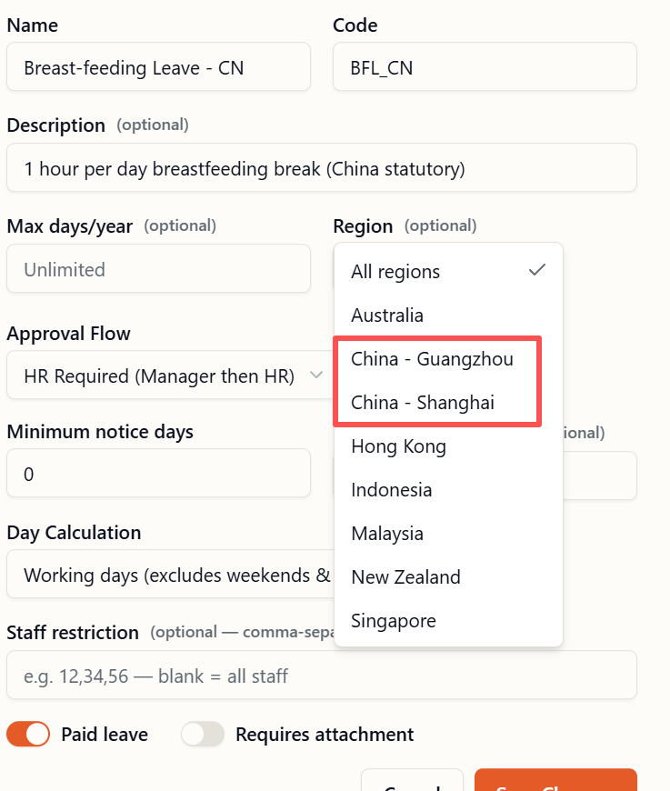
- For example, Marriage Leave, only unmarried staff are eligible for marriage leave. Need to add the functions to select the unmarried staff. Parental Leave-CN, Care Leave-CN, etc. are only available to eligible staff. Maybe can add the “Staff (optional)” option next to “Region (optional)” to select more than one eligible staff.
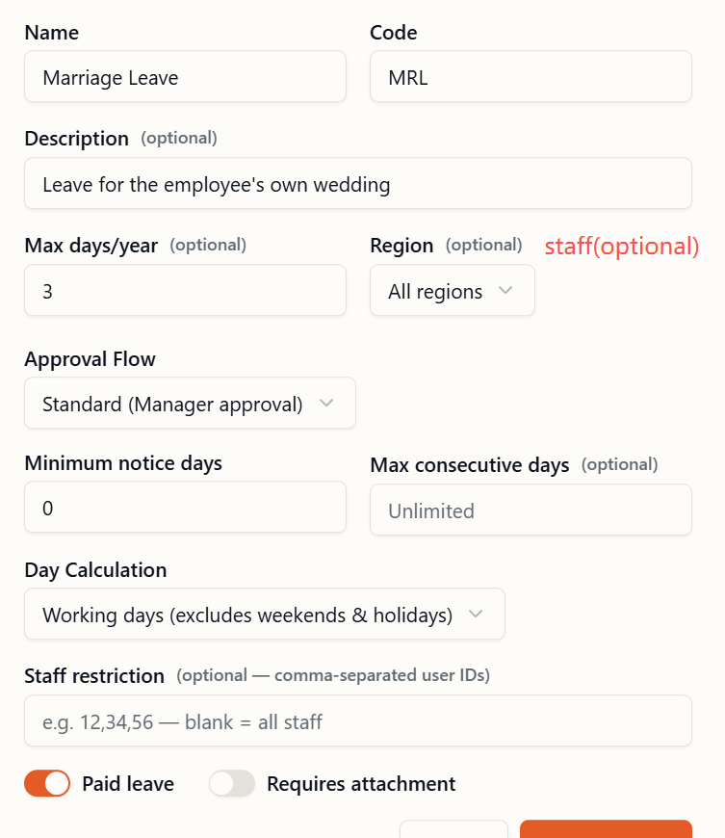

For Admin- Policies

For the same leave type, different staff in same region have different entitlement days. For example, annual leave in Guangzhou, some staff have 12 days, some 14 days, some 15 days and some 16 days. A function needs to be added to categorize staff into different entitlement days, similar to the Calamari system. For example, add entitlement days 1: 12 day and can select more than one staff, add entitlement days 2: 14 day and can select more than one staff, add entitlement days 3: 15 day and can select more than one staff, and so on.
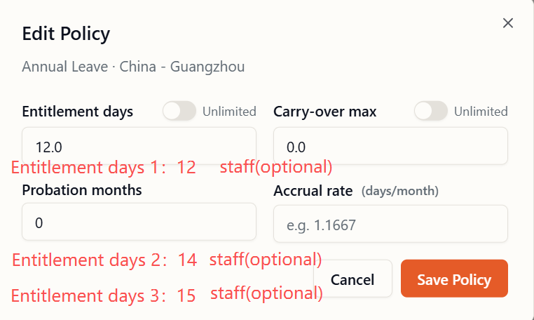

For Admin- Entitlements

For edit entitlement- adjustments, need to increase or decrease the number of days based on the original entitlement days.

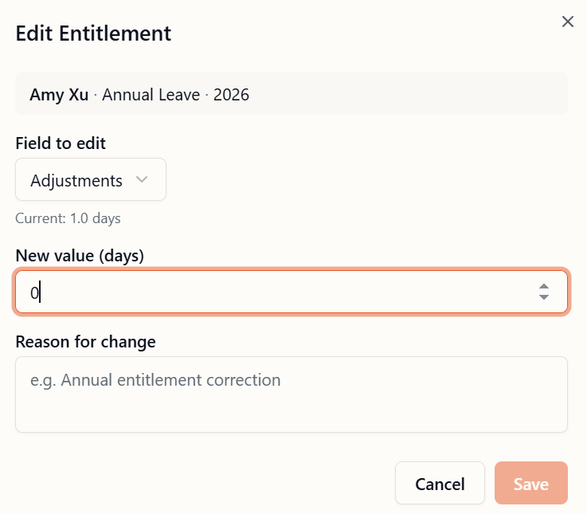
For Request Leave

- If can show the number of days of leave on the page after selecting the leave dates?

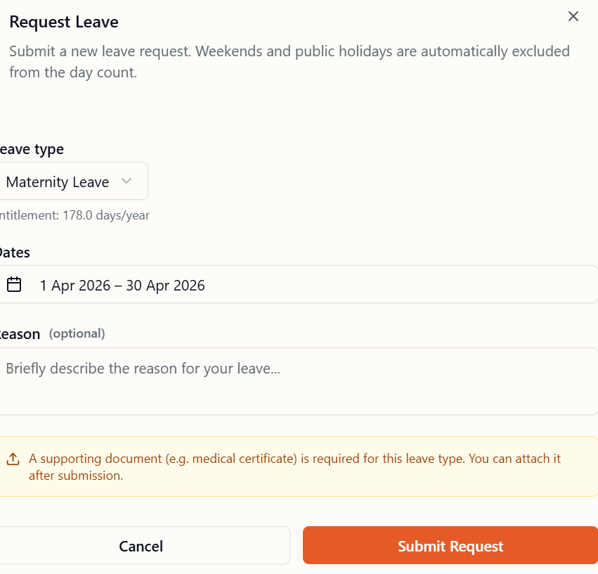

- Need to add the function to choose the time. For example, Breast-feeding Leave - CN (1 hr per day), can choose the time 9:00pm-10:00pm or 5:00pm-6:00pm on working day. For half day, maybe also need to choose the time.

- Need to add the function to choose the minimum unit of leave request on Admin- Leave Types or Policies, the minimum unit is 1 hour…..4 hours (0.5 day) etc. Otherwise, it might be impossible to choose a one-hour time slot (9:00am-10:00am or 5:00pm-6:00pm) for breastfeeding leave.

